Worksheet -2.3

## NAME –Vivek SUBJECT – DBMS

**UID –212122 DATE OF PERFORMANCE**

## CLASS – SEMESTER - 3rd

**Question 1 :** Write a program in PL/SQL to showthe uses of SQL

### %FOUND to determine if a DELETE statement

affected any rows.

**Steps of experiment/practical/code:**

# DROP TABLE emp_temp; CREATE TABLE

emp_temp AS

# SELECT employee_id, first_name, last_name FROM employees;

CREATE OR REPLACE PROCEDURE test_proc (

z_emp_id NUMBER

) AUTHID DEFINER AS BEGIN

DELETE FROM emp_temp WHERE employee_id = z_emp_id;

IF SQL%FOUND THEN DBMS_OUTPUT.PUT_LINE (

'Delete succeeded for employee_id: ' || z_emp_id

); ELSE

DBMS_OUTPUT.PUT_LINE ('No employee of ID '|| z_emp_id||'is found.'); END IF;

END;

/ BEGIN

test_proc(175); test_proc(444); END;

/

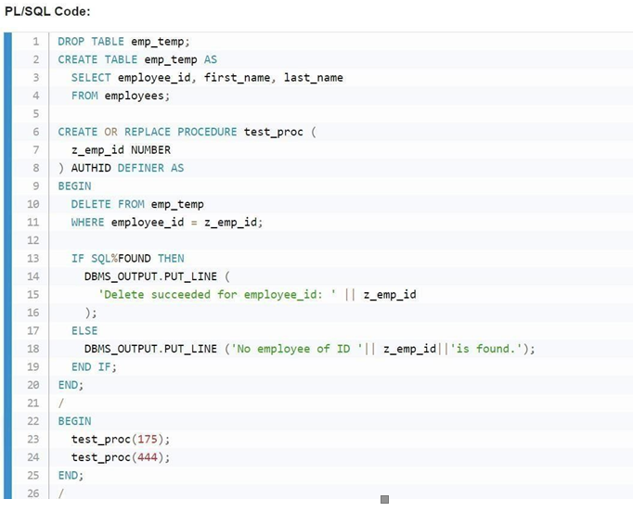

**OUTPUT :**

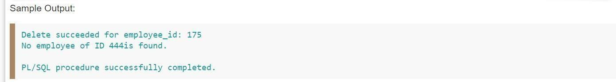

**Question 2 :** Write a PL/SQL block to display the last name of manager, and their departments for a particular city, using parameters with a default value in explicit cursor.

### Steps of experiment/ practical/ code:

DECLARE

CURSOR emp_cur (dep_location NUMBER DEFAULT 1700) IS SELECT d.department_name,

e.last_name manager, l.city

FROM departments d, employees e, locations l WHERE l.location_id = dep_location

AND l.location_id = d.location_id

AND d.department_id = e.department_id ORDER BY d.department_id;

PROCEDURE dep_cur IS

depname departments.department_name%TYPE; dep_mgr employees.last_name%TYPE; dep_in_city locations.city%TYPE;

BEGIN LOOP

FETCH emp_cur INTO depname, dep_mgr, dep_in_city;

DBMS_OUTPUT.PUT_LINE(rpad(depname,35) ||rpad(dep_mgr,15)|| dep_in_city); END LOOP;

END dep_cur;

BEGIN

DBMS_OUTPUT.PUT_LINE('DEPARTMENTS AT :'); DBMS_OUTPUT.PUT_LINE(' ');

DBMS_OUTPUT.PUT_LINE(rpad('Department',35)||rpad('Manager',15)||'City'); DBMS_OUTPUT.PUT_LINE(' ');

OPEN emp_cur; dep_cur;

CLOSE emp_cur;

DBMS_OUTPUT.PUT_LINE(' ');

OPEN emp_cur(1400); dep_cur;

CLOSE emp_cur; END;

/

## OUTPUT :

